1. **Preparation of stepping motors**

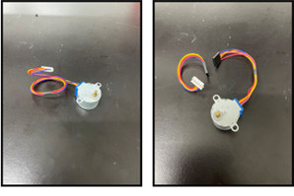

* Cut the wires down the middle to extend the wiring for the 28BYJ48 stepping motor and install the female pin and housing. Five stepping motors are prepared.

1. **Preparation of jack connector**

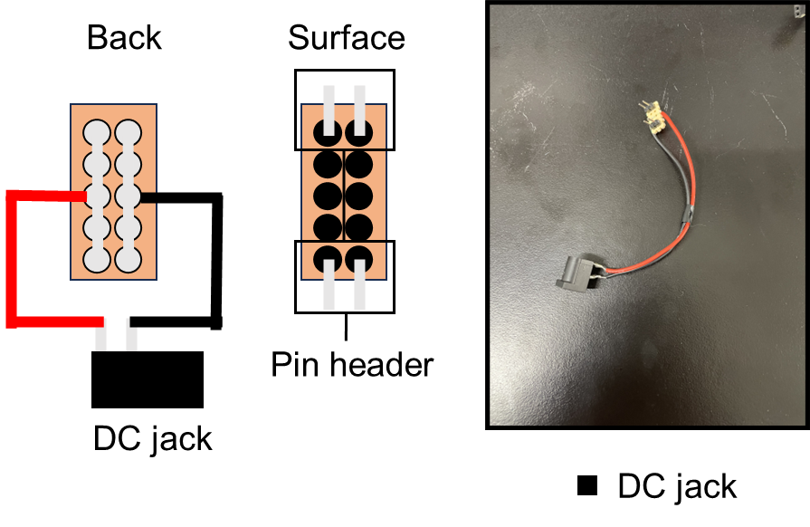

* To make power source connector, the anode and cathode portions of the DC Jack are connected via wires to the excess portion cut out when the LED array board is made with soldering. After that, the pin headers are attached with soldering (Supplementary Fig. 2K).

1. **Preparation of camera**

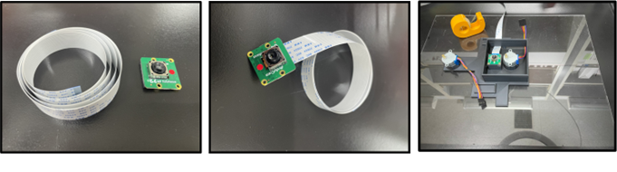

* Camera module is connected with ribbon cable for camera.

1. **Printing parts**

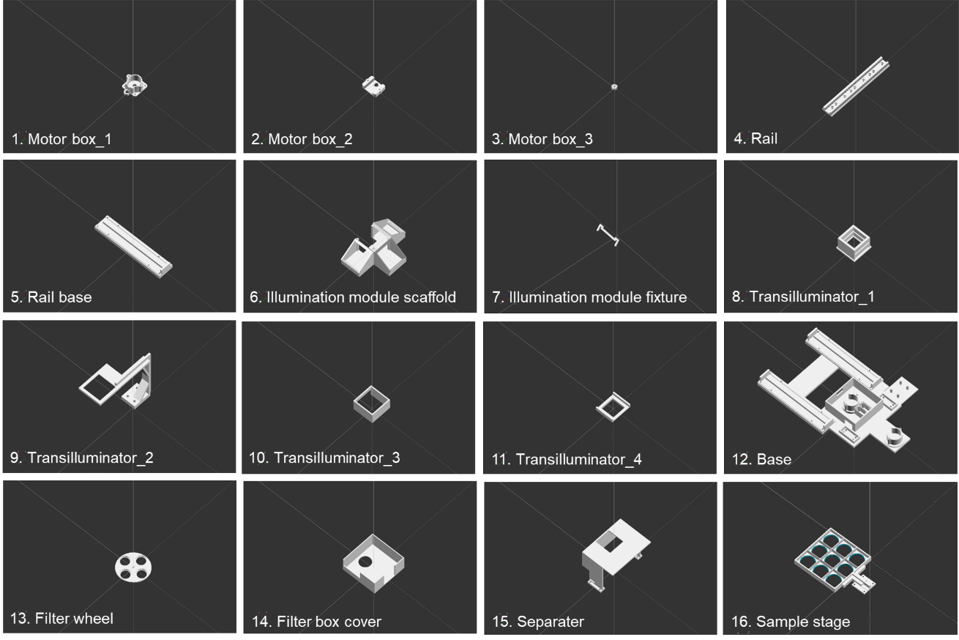

* Print the parts using a 3D printer. (3D printer: Anycubic Kobra 2 MAX; Infill: 20%; Layer height: 0.2mm). Prepare three of each part numbered 1 - 4.

1. **Assembly of stepping motor box**

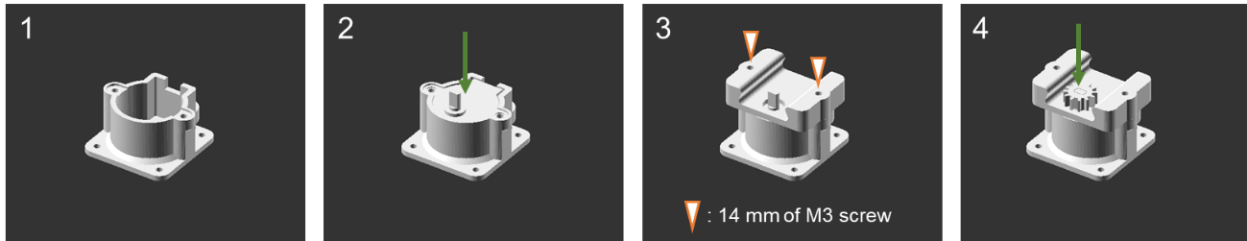

* The stepper motor are fitted into the motor box, the rail sliding section is secured to the main body with M14 screws, and the gear is fitted onto the shaft. A total of three motor boxes are created (Preparerd three pieces)

1. **Assembly of 2D actuator**

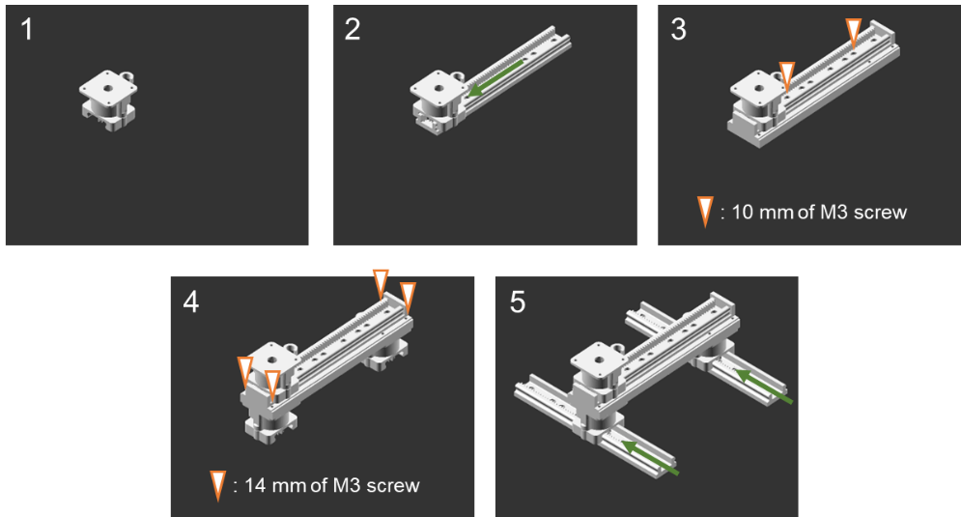

* Thread the X-axis motor box onto the rail and secure the rail to the X-axis rail base with screws. Secure the two motor boxes to the X-axis rail base with screws, then thread the rail onto the Y-axis motor box.
* ※Be careful not to insert the rail in the wrong direction, as this may cause the actuator to malfunction.

1. **Preparation of illumination module**

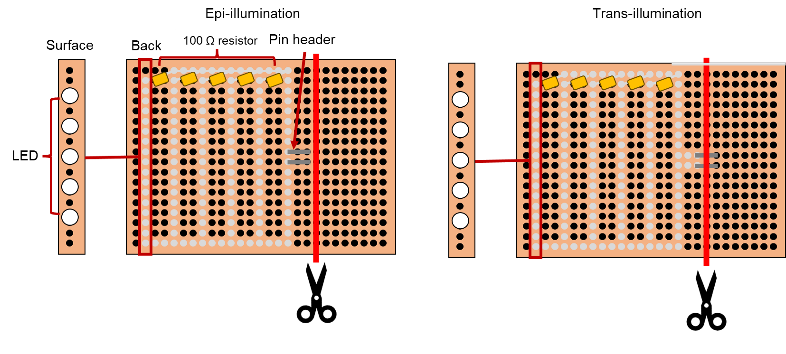

* To make light source table, totally, 25 Light emitting diodes (LEDs) are soldered on a 50 mm ×70 mm PCB base. In the series direction, LEDs are soldered with one hole skipped. In addition, resistances are soldered on the edge of each LED arrays. In the parallel direction, LED arrays are soldered with two holes skipped. Resistances value which is connected to each LED arrays is calculated using Ohm’s law formula. Additionally, trimm off the excess parts of the board with wire cutters.

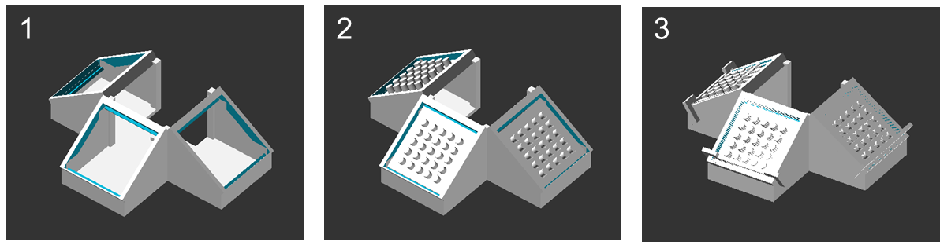

* Attach the prepared LED array to the illumination module scaffold and fixed by fixture.

1. **Preparation of transilluminator**

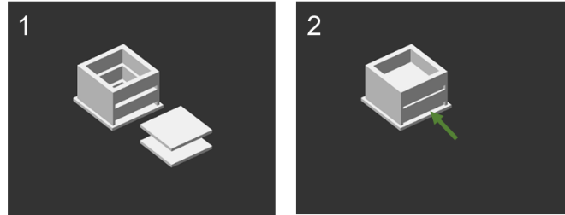

* Cut out two 44mm x 46mm squares from acrylic board. Attach the acrylic boards to Transilluminator_1.
* Used acrylic plate (https://www.hazaiya.co.jp/products/detail/3351)

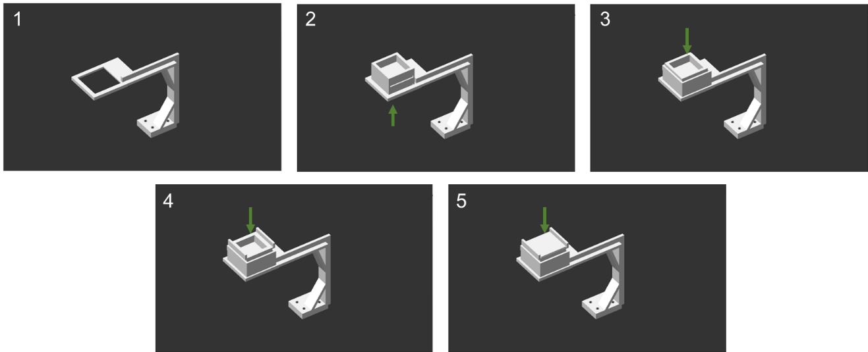

* Attach Transilluminator_1, Transilluminator_3, Transilluminator_4, and the LED array to Transilluminator_2.

1. **Preparation of wire**

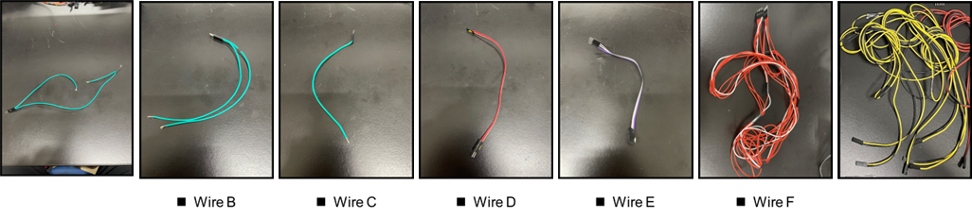

* To make the jumper wire to connect the Raspberry pi to each parts, Totally, Seven jumper wire sets are prepared.

1. **Assembly of device**

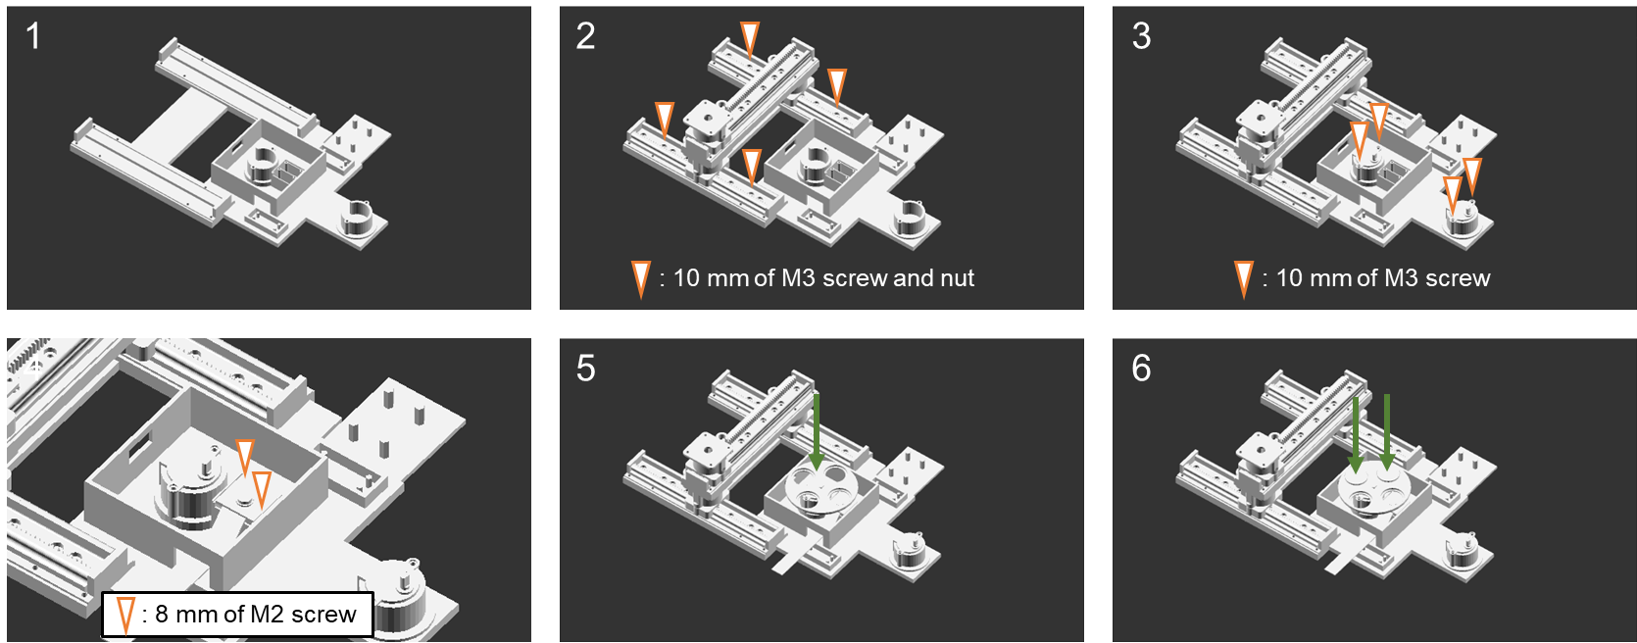

* Attach the assembled 2D actuator to the base using screws and nuts.
* Attach the two stepper motors to the base with screws.

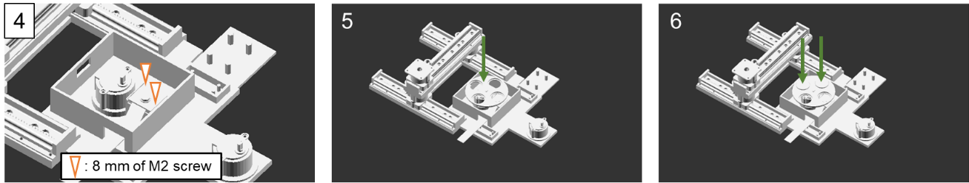

* Attach the camera with the ribbon cable to the Base using screws.
* Ribbon cable was connected to camera port of Raspberry pi 4 model B
* Attach the filter wheel to motor shaft and optical filters.

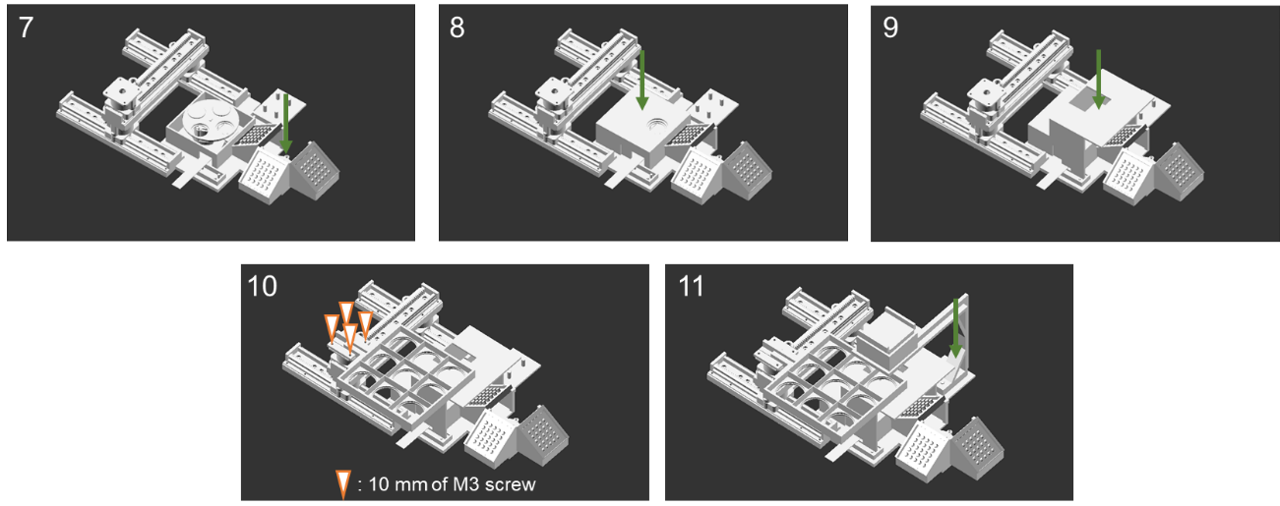

* Attach the illumination module.
* Attach the filter box cover (It doesn't matter whether you put it on or not.).
* Attach the separator.
* Attach the sample stage.
* Attach the transilluminator.

1. **Wiring with relay module**

Wiring position of GPIO pins



* **Use pin name (pin number and pin name) to specify subsequent GPIO pins.**
* **When connecting GPIO pins to each module via the breadboard, route the wires one row inward from the breadboard's + and - sections. (This prevents the breadboard wiring from interfering when attaching the expansion board later.)**

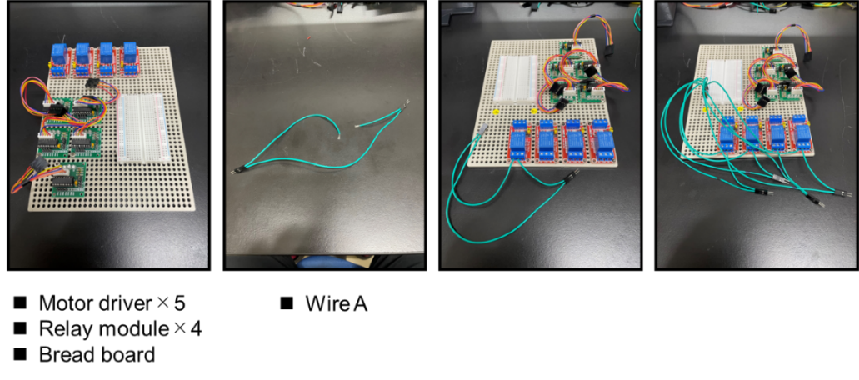

* 18v power are connected to the COM and NC channel of the relay modules via bread board using wire A.

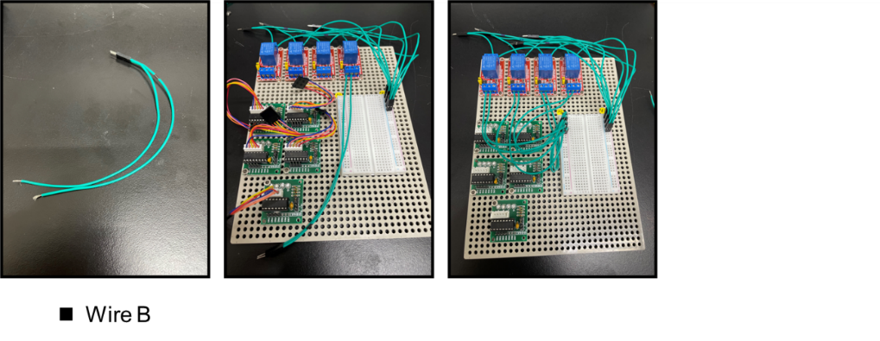

* Anode of 5v power are connected to the anode of logic power portion of the relay modules and cathode of 5v power are connected to the cathode of logic power portion of the relay modules via a bread board using wire B.

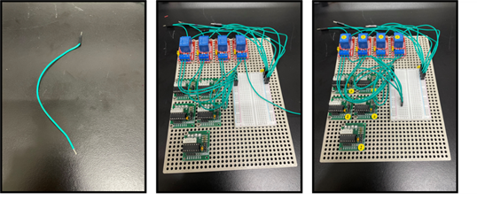

* The Raspberry GPIO 14, GPIO 15, GPIO 18 and GPIO 23 (pin number) are connected to input of the relay modules via a bread using wire C. It is advisable to label the relay module corresponding to the light source (relay module1- white, relay module2 -blue, and relay module3 green) used.

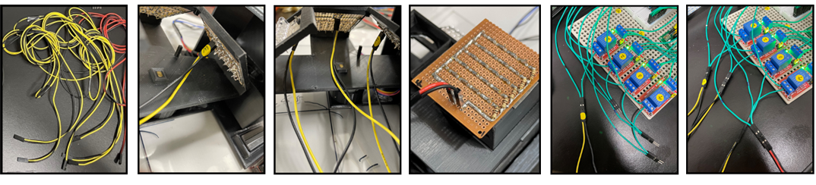

* Anode of LED arrays are connected to anode of 18v power and cathode of LED arrays are connected to cathode of 18v power using by wire G with wire A (relay module1 to white LED array, relay module2 to blue LED array, relay module3 to green LED array, relay module4 to white LED array attached to transilluminator).

1. **Wiring with stepping motors**

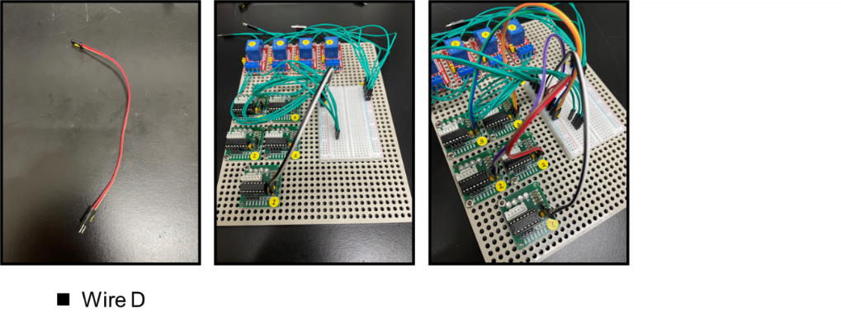

* Anode of 5v power are connected to the anode of logic power portion of the stepping motor control module and cathode of 5v power are connected to the cathode of logic power portion of the stepping motor control module via a bread board using wire D.

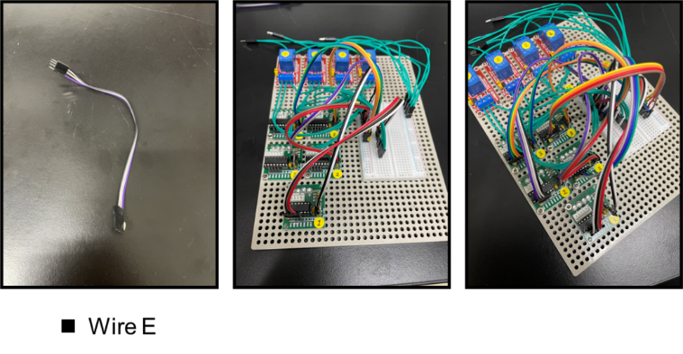

* The Raspberry GPIO 24, GPIO 25, GPIO 8 and GPIO 7 are connected to input portion of the stepping motor control module via a bread using wire E (from GPIO 24, GPIO 25, GPIO 8 and GPIO 7 to stepping motor control module1 IN1, IN2, IN3 and IN4).
* The Raspberry GPIO 12, GPIO 16, GPIO 20 and GPIO 21 are connected to input portion of the two stepping motor control modules via a bread using wire E (from GPIO 12, GPIO 16, GPIO 20 and GPIO 21 to two stepping motor control modules2 IN1, IN2, IN3 and IN4).
* The Raspberry GPIO 4, GPIO 17, GPIO 27 and GPIO 22 are connected to input portion of the two stepping motor control modules via a bread using wire E (from GPIO 4, GPIO 17, GPIO 27 and GPIO 22 to stepping motor control modules3 IN1, IN2, IN3 and IN4).

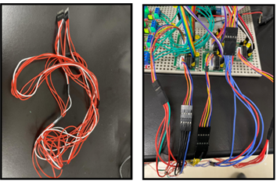

* Stepping motor driver modules are connected to the stepping motor using wire F (stepping motor control module1 to stepping motor attached to x axis actuator, two stepping motor control module2 to stepping motors attached to y axis actuators, stepping motor control module3 to stepping motor attached to the filter table and light source table).

1. **wiring with power and GPIO pin expansion board**

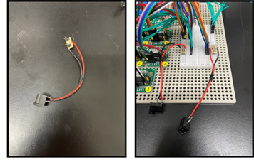

* Power source connectors are attached to the bread board.

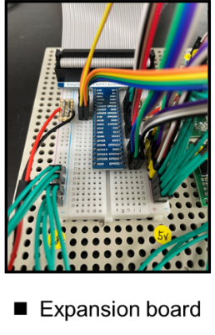

* The Raspberry pi GPIO pins are connected to bread board with an expansion board. Install the GPIO 14 of expansion board to the wire connected to the relay module_white.

**Complete!!**

**Next is test running**

**Comments**

* Note that 18V is used as the power supply for the LEDs, while 5V is used as the logic power supply for each module.
* Before operating the device from the microcontroller, lubricant should be applied to the rails.
* When stopping the device, ensure all motion has ceased before stopping CU.py.
* If you need to stop the device mid-operation, stop CU.py and then reboot the Raspberry Pi. Touching the device before rebooting may cause damage.
* If the device moves poorly or does not move at all, there is likely a wiring issue. Check that all wires are connected to the correct terminals and are not damaged.